**BKM for PythonSV and Cscripts setup**

Configure ITP

Download CScripts from Intel website using login credentials and search for the string “Eagle stream cscript”.

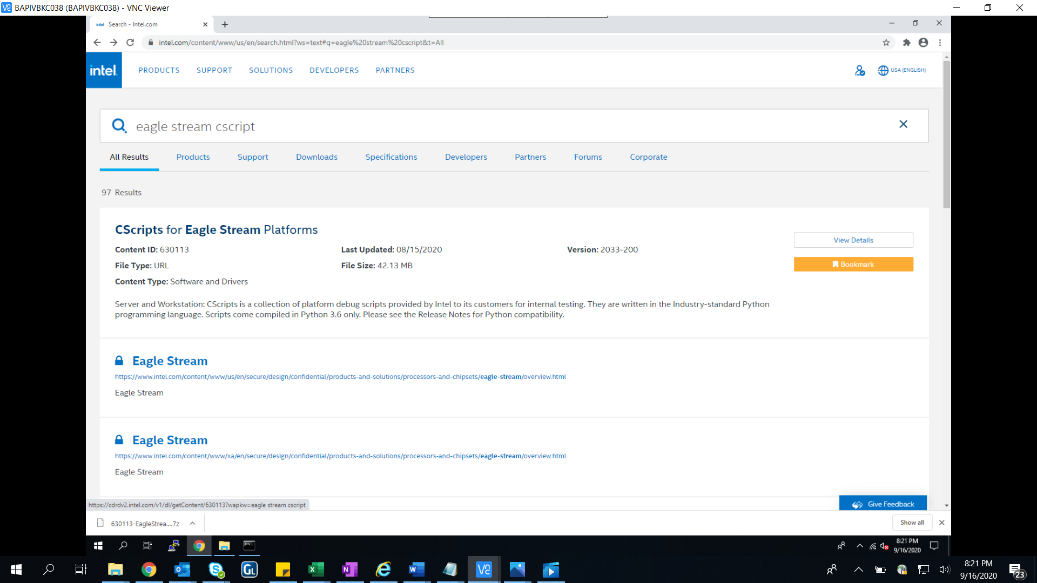

Unzip using the 7z and copy CScripts folder in C drive

Open command prompt in Admin mode and verify the system name using below command and also cscripts file

C:>hostname

C:>cd cscripts

For External available required packages :

If below file is not present then get it or copy from old cscripts folder.

C:\cscripts>type requires_external.txt

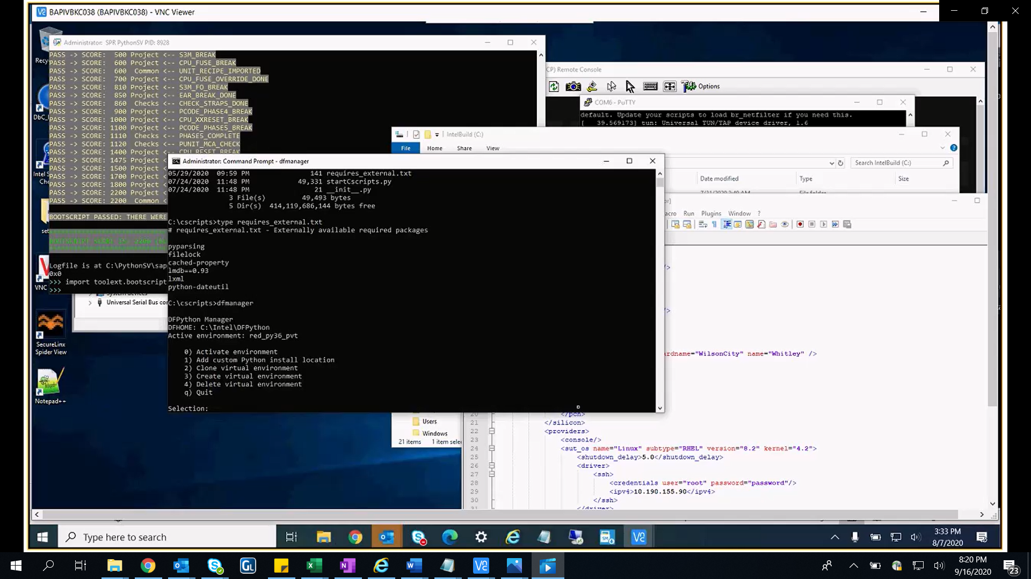

**To activate Environment,**

1. Run the commands for virtual python setup

PS C:\cscripts> **dfmanager**

DFPython Manager

DFHOME: C:\Intel\DFPython

Active environment: system_py36

    0) Activate environment

    1) Add custom Python install location

    2) Clone virtual environment

    3) Create virtual environment

    4) Delete virtual environment

    q) Quit

Selection: 0

Select the environment to activate:

    0) [CPython]system_py36-C:\Python36\python.exe

    b) Back

    q) Quit

Selection: 0

Warning: This virtual environment was not generated with dfmanager

Environment successfully activated!

PS C:\cscripts> **dfmanager**

DFPython Manager

DFHOME: C:\Intel\DFPython

Active environment: [CPython]system_py36-C:\Python36\python.exe

    0) Activate environment

    1) Add custom Python install location

    2) Clone virtual environment

    3) Create virtual environment

    4) Delete virtual environment

    q) Quit

Selection: 3

Select color classification:

    0) red

    1) white

    b) Back

    q) Quit

Selection: 1

Select python install:

    0) C:\Python36\python.exe

    b) Back

    q) Quit

Selection: 0

Enter virtual environment name (Must start with a letter. Letters, numbers, '_' and '-' are permitted)

Name: cscripts

Creating virtual environment, this may take a while...

Virtual environment successfully created!

Name: white_py36_cscripts

Path: C:\Intel\DFPython\virtualenv\white\py36\cscripts

Environment successfully activated!

1. Install required python libs

       PS C:\Users\lab_bacrse\Downloads> **dflaunch -s**

DFHOME: C:\Intel\DFPython

Launching virtual environment...

current_env: white_py36_cscripts

current_env_path: C:\Intel\DFPython\virtualenv\white\py36\cscripts

color: white

python_version: py36

       [white_py36_cscripts] C:\cscripts> **pip install --proxy=proxy-chain.intel.com:911 -r requires_external.txt**

Provide the credentials

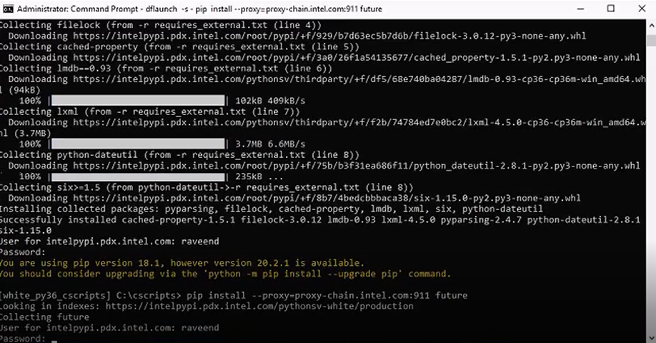

packages to install:

[white_py36_cscripts] **C:\cscripts>pip install --proxy=proxy-chain.intel.com:911 future**

[white_py36_cscripts] **C:\cscripts>pip install --proxy=proxy-chain.intel.com:911 ipccli**

[white_py36_cscripts] **C:\cscripts>pip install --proxy=proxy-chain.intel.com:911 pyreadline**

[white_py36_cscripts] **C:\cscripts>pip install --proxy=proxy-chain.intel.com:911 pylib2**

[white_py36_cscripts] **C:\cscripts>pip install --proxy=proxy-chain.intel.com:911 xmltodict**

[white_py36_cscripts] **C:\cscripts>pip install --proxy=proxy-chain.intel.com:911 -r C:\dtaf\dtaf_content\requirements_py3.txt**

Install all the packages in same way whichever is required.

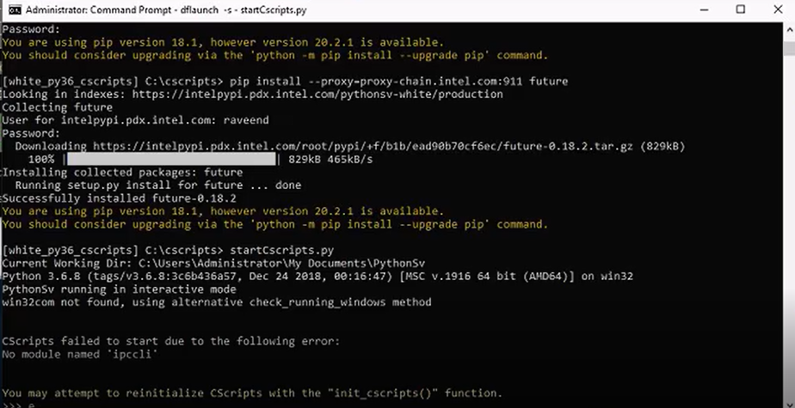

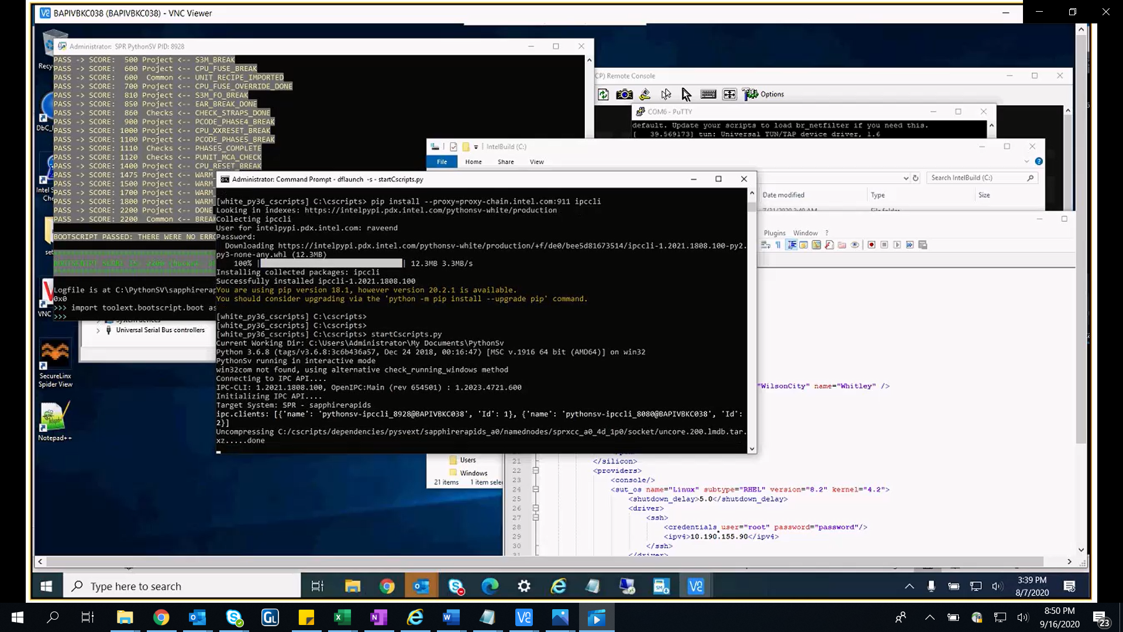

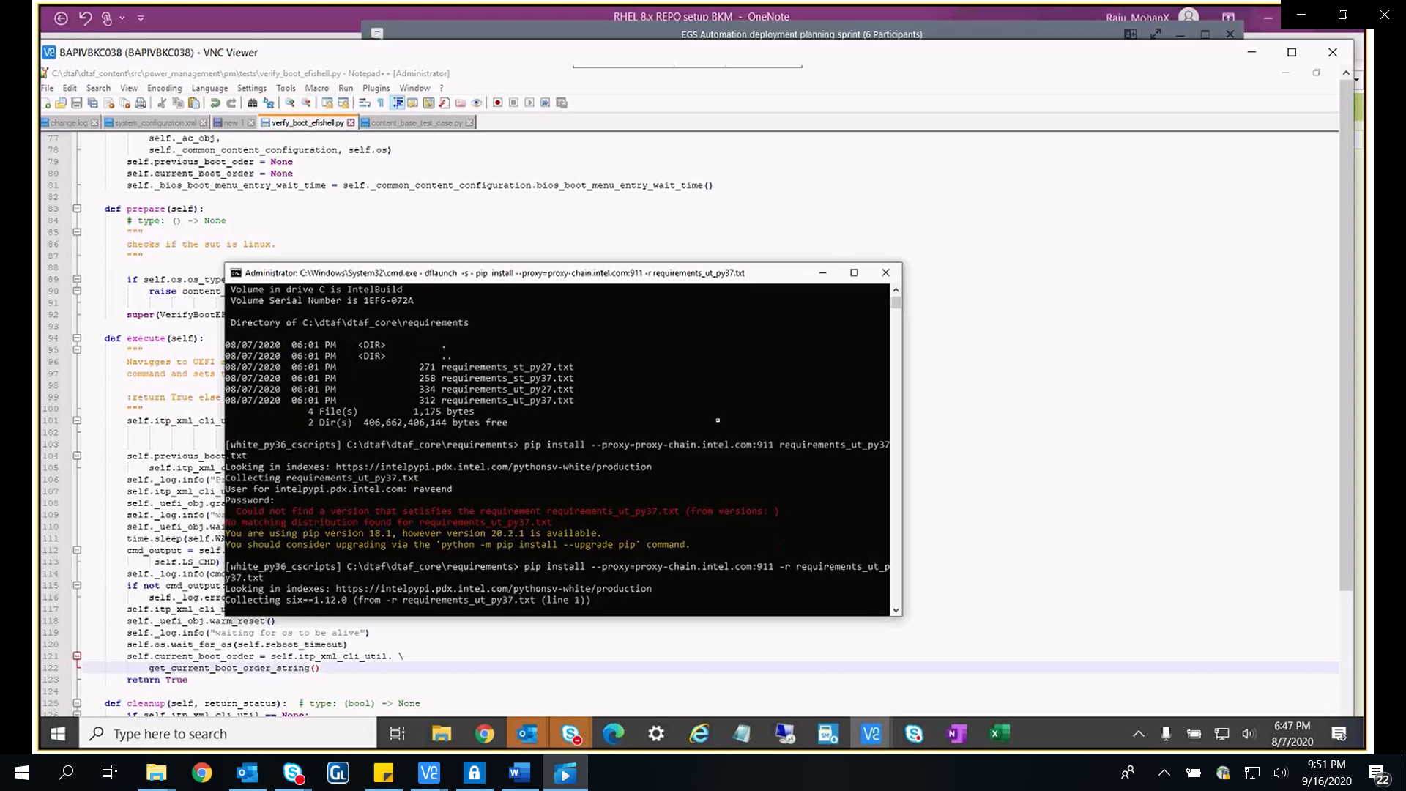

**C:\cscripts> startCscripts.py**

Create or edit environment variable PYTHONPATH and the set value of this environment variable as c:\DTAF\DTAF_Core\src;c:\DTAF_Content; along with C:/Python36/scripts or wherever Python36 folder is present.

Note: if you are running test cases which require ITP, PysthSV and CScripts, also include PythonSV, CScripts and other DAL related paths to this PYTHONPATH.

**Note: Updatetools file is there in C:/PythonSV/sapphirerapids folder, run(by double clicking) that to update PythonSV.**

* If you want to install pip anytime then run below command:

**c:\Python36>dir /s get-pip.py**

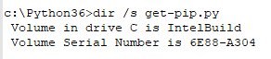

**c:\Python36\Lib\site-packages\svtools\ipip>python get-pip.py --proxy** [**http://proxy-chain.intel.com:911**](http://proxy-chain.intel.com:911)

* Download all the packages in requirements file for dtaf core and content repos.

1. **c:\dtaf\dtaf_core\requirements>pip install -r requirements_ut_py37.txt --proxy** [**http://proxy-chain.intel.com:911**](http://proxy-chain.intel.com:911)

If you get following error while running above command then uninstall six

tox 3.19.0 requires six>=1.14.0, but you'll have six 1.12.0 which is incompatible.

svtools-axon-diff 1.2.0.600 requires openpyxl<3.0.4, but you'll have openpyxl 3.0.4 which is incompatible.

Successfully installed apipkg-1.5 astroid-2.4.2 execnet-1.7.1 fabric-2.5.0 invoke-1.3.0 isort-4.3.21 junit-xml-1.8 lazy-object-proxy-1.4.3 mccabe-0.6.1 mock-3.0.5 paramiko-2.6.0 pathlib2-2.3.5 pylint-2.5.3 pyparsing-2.4.7 pytest-5.2.2 pytest-cov-2.8.1 pytest-forked-1.3.0 pytest-html-2.0.0 pytest-metadata-1.8.0 pytest-mock-1.13.0 pytest-pythonpath-0.7.3 pytest-xdist-1.34.0 six-1.12.0 wrapt-1.12.1

**c:\dtaf\dtaf_core\requirements>pip uninstall six**

and then again do following:

**c:\dtaf\dtaf_core\requirements>pip install -r requirements_ut_py37.txt --proxy** [**http://proxy-chain.intel.com:911**](http://proxy-chain.intel.com:911)

1. **pip** **list** command will show all the packages.

**c:\dtaf\dtaf_content>pip install -r requirements_py3.txt --proxy** [**http://proxy-chain.intel.com:911**](http://proxy-chain.intel.com:911)

**To install components folder in PythonSV folder.**

cd C:/PythonSV/__install__

C:/PythonSV/__install__>checkout.py

Select 56 i.e. components option, it will install components folder.

**Need to config ITP Unlocker**

1. Login to https://uldll.pdx.intel.com/Downloads.aspx?r=1392161403 in web browser using your window credentials like

UserId- gar\userxx

Password-pass

1. Download PushUtil.zip package and extract it.
2. Copy PushUtil folder to C: drive.
3. Open folder and run “PushUtil.exe” in admin mode.(Prerequisites- .Net framework and dll need to be installed if you get any error regarding this)
4. Copy host-names.txt in PushUtil folder.
5. Import this file in SVE PushUtil Unlocker XML window and you will see all the hosts in hostname column as shown in below figure:

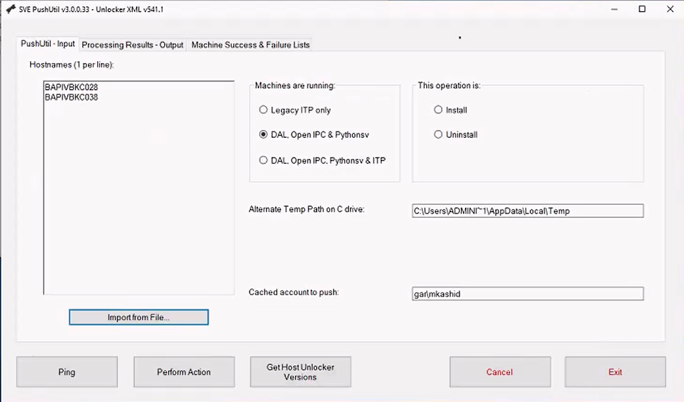

1. Click on “Perform Action” button then we will see both hostnames as success.
2. Open command prompt in admin mode an perform following, if any issues occur, update PythonSV.(refer below screenshot)

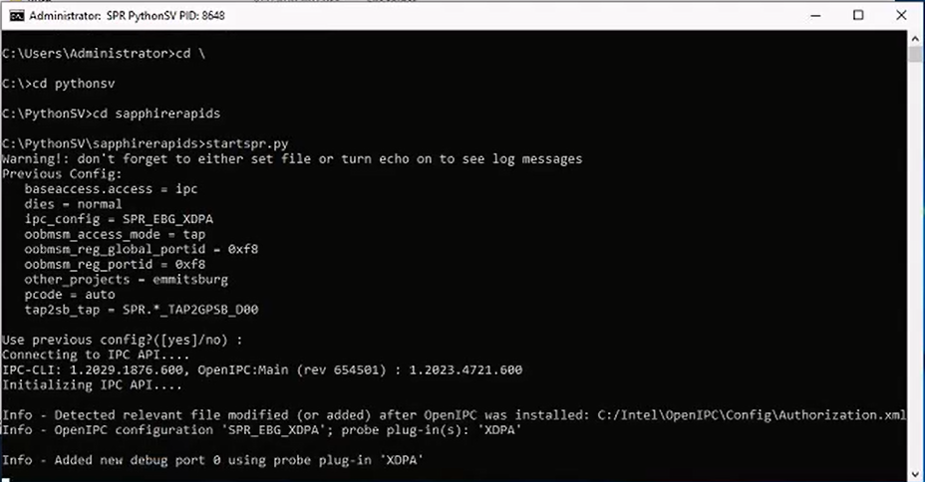

Use below to install ipccli package:

pip install --proxy=http://proxy-chain.intel.com:911 --index-url=https://intelpypi.pdx.intel.com/pythonsv-white/production ipccli

ITP Halt issue:

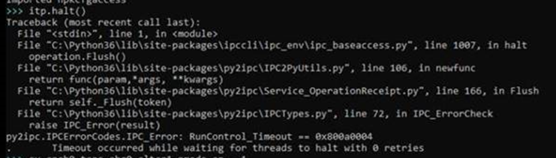

Below is the solution for itp halt issue.s

If you are using A2 silicon system and not able to halt the system, please follow the below procedure.

**OpenIPC  should be updated to new version.( OpenIPCDebugLibrary.pvt.1.2036.4891.600.x64.msi)**

1. Uninstall old OpenIPC from control panel in your host à open IPC Debug Library

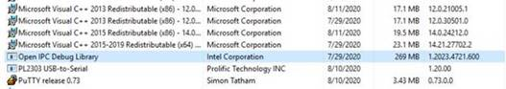

1. After un-installing older one install the new oneà copied in share path

\\bapivbkc004\coMMON\open_IPC_SPR

1. After updating the new OpenIPC you can halt the A2 silicon boards.